This instruction document describes how to split expense costs over multiple subprojects.

# Login to Unit4 to claim your expenses

By following the URL you can log on to the Live Unit4 system:

https://agressoweb.hud.ac.uk/MS7_Live_Web/Login/Login.aspx

Alternatively, via the **Staff Hub** internet page login:

From the tab **‘Online Systems’**, locate the link for ***Unit4****.*

The following Login box should appear.

* Enter the details requested and then click the **LOGIN** button.

**User name**: the same as your computer login e.g. FINATP

**Client**: is the University company to be used

Client = **H1** (Main company)

**Password**: must be at least 6 digits and include a number.

**Forgotten your password?** -

click on the link to reset

# Time and expenses navigation

* From the **Menu** select **Time and expenses** and **Travel expenses**

# Set up of Travel expenses

**Tab1 - General:**

* **Status:** choose either **Draft** or **Ready** (for approval)
  + **Draft** – see page 6 for further information
  + **Ready** – to submit the claim
* **Resource:** defaults to your name
* **Travel type:** chooseeither **Expense** or **Advance** in the drop-down menu
* **Purpose:** enter an appropriate and specific purpose of the expenses claim: e.g. *Conference ABC – Manchester - date*.

NB: “Trip” or “Travel” is not sufficient, as the purpose will become the description for the general ledger posting line.

* **Comment:** further comments, notes can be entered here for the Budget Holder or School Finance Office.

* When all fields have been populated click on **Next step icon**, moving on to **tab 3 – Expenses**.

# Adding expense lines

Tab **3 - Expenses** is the screen where expense lines are input.

* A screenshot of a computer

  AI-generated content may be incorrect.Click on **Add** to insert an expense line.

**Expense items:**

* **Expense details:** choosethe correct **Expense type** from the drop-down menu and click or tab on to reveal more details in this screen.

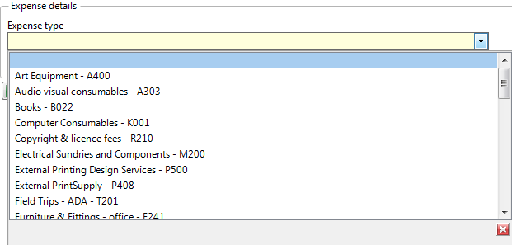

* **Description:** enter an appropriate and specific description for the expense line.
* **Date:** enter the date the expense occurred.
* **Amount:** enter the full cost of the expense item (100% value before split).

* **Tab on** to reveal the **GL Analysis** section.

**GL Analysis:**

* **Nominal:** will auto populate from the Expense type selected earlier - no need to update.
* **Subproject:** enter one subproject, just one single budget code of the claim.

**NB**: to split expense claim costs across budgets you must have access to the subprojects to do this.

# Attaching a document to the expense claim

* When you have input all details for the expense the line, from this expense line (the whole line will be marked in blue) click on the **paper clip icon**

in right top corner to add receipt evidence to this line.

* Click on **Add a document** icon and then select **Expense receipt**.
* **Document type:** select from the drop-down **Expense receipt**.
* **File name: Upload**.

* Click on **Upload** to select the file/receipt you want to upload and navigate to the receipt to be attached.
* Click on the file and **Open** to attach.
* Close the window (**x**) to return to expense claim.

# Cost distribution

* On the bottom tool bar click

The cost distribution option now opens:

* Click **Add** to add a line into the cost distribution table.
* enter the first **subproject** you need to *split* the cost between.
* **tab on** and enter the **percentage** value you want to distribute to this subproject.
* Click **Add** again to add another line to the cost distribution table.
* enter the next **subproject** you need to *split* the cost between.
* **tab on** and enter the **percentage** value you want to distribute to this subproject.

**NB**: continue to add further lines if for example split over 3 subprojects, etc.

**NB**: ensure the total value is **100.00**.

*Example:*

* Click on the expense line to split, *cost distribution* – **tick** to *Mark item to distribute.*

* Click **Apply cost distribution**.

*Example setup:*

***1.*** *add the subprojects,* ***2.*** *add the percentage splits,* ***3.*** *mark the expense line to split,* ***4.*** *Apply cost distribution*

*Results example:* Cost distribution applied

* **Close Cost distribution**: to return to the *Add expense window*, now showing the split lines.

**NB**: click **Add** to input further expense lines to the claim and follow the instructions above to attach evidence to the expense claim and split costs where needed.

# Submitting the expense claim or saving as a ‘Draft’

When you are ready to submit the expense claim for **approval**:

* **tab1-General** – return to this tab ensure the **Status** is set to **Ready** and click **Save** in the left bottom corner.

The **Success** message will advise the claims **Transaction number**.

**Alternatively** - if you are to continue to add to the expense claim later, the **Status** needs to be **Draft** and click **Save**.



## **Reviewing the ‘Progress’ of an expense claim and accessing a ‘Draft’**

* Login to Unit4 and navigate to **Your employment** click on **Expenses** to locate the **Expense overview** section.

By clicking on **Drafts** you can access and continue to work on any *drafts* you have previously saved.

**In progress:** will list any expense claims you have submitted into workflow for approval.

*Expense claim workflow details:*

Once accessed **In progress**, you can click on an expense line listed to view the details of the claim.

**NB:** you cannot amend a claim that has entered the workflow, the expense opened via *In progress* is *viewing* only. If you have any queries about your *claim in progress* at this point*,* contact your school finance team or budget holder, the relevant approver step.

**Completed:** when clicked onshows claims that have historically been paid to you. This is helpful if you need to check whether you submitted an expense claim for a certain trip in the past.