Budget Holders Expenses Approval Procedure
Overview
This guide explains the Unit4 workflow and responsibilities for approving expense claims as the Budget Holder role.
Understanding the Workflow of an Expense Claim:
Is the claimant from a School?
- Yes - the workflow directs the claim to the School Finance Team before it reaches the Budget Holder review task.
What the School Finance Team reviews:
Date of claim, time lapse
- To review that the expense claim has been submitted in a timely manner.
Claims should be made within one month of the expense being incurred, or within one month of returning from the trip.
Expense type, the Nominal
- Checking if the claim is valid and that the correct expense type category has been selected.
Subproject
- If the claim uses the dummy subproject code EXPxxx-01, this must be replaced with a valid subproject that aligns with the nature of the claim. This ensures the workflow routes correctly to the appropriate Budget Holder for review.
Description
- The description is checked to ensure the details provided are clear, relevant and accurately reflect the expense.
Amount
- The amount claimed is reviewed to confirm it matches the value shown on the attached receipt.
Receipts
- To ensures valid receipts are attached to support the claim.
Wherever possible, VAT invoices should be provided so the University can recover the full amount of VAT it is entitled to.

Is the claimant from a Service?
- Yes - if the claimant is from a Service, the workflow progresses the expense claim directly to the Budget Holder for review.
- It is the responsibility of the Budget Holder to review the claim details as described above.

Approval considerations:
- The expense claim must be reviewed carefully and if any details are missing or unclear, the Budget Holder should reject the claim.
Full Travel and Expense Claim Policy details can be found: https://staff.hud.ac.uk/media/policydocuments/Expenses-and-Benefits-Policy-and-Procedure.pdf

Task notifications:
The Budget Holder will receive an email notification when a new claim requires approval.
- Clicking the link in the email will take you directly to the Unit4 login page.
Example:
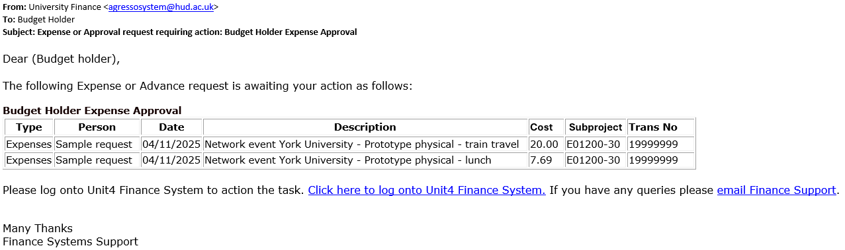

Approving an Expense Claim:
- Log into Unit4 and open the expense claim by clicking the task icon.
- Click on an expense line to open an expense claim to view the full claim information.
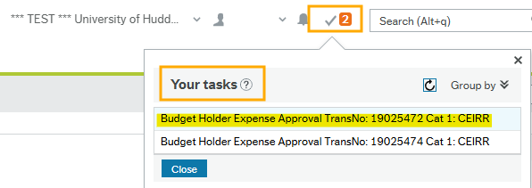

Reviewing Travel Expenses
The approval screen will display the details of the expense claim, which include claimant name, purpose, expense lines and subproject details.

The General section displays the basic details of the claimant and the expense claim.
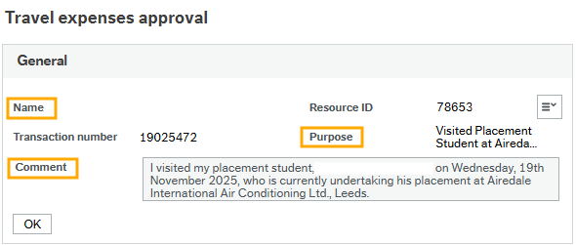
Sample

The Expenses section of the claim is displaying the expenses lines to check.

- Clicking the first line of the claim (highlighted in blue), the expense details for that line will appear in the Expense Details section for review.
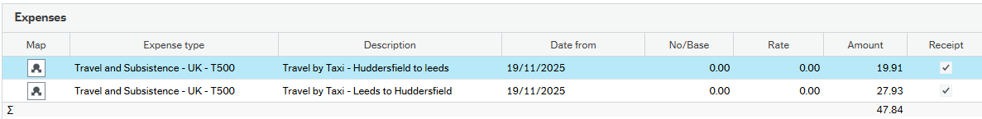

The Expenses details section displays the details of the selected expense line:
Expense Type: the category or nominal of the expense.
Description: details of the expense line being claimed
Amount: the value to be claimed
Date: the date the expense was incurred
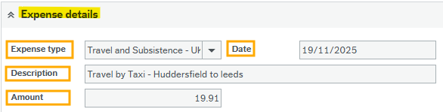

The GL Analysis (General Ledger) section displays further ledger details of the selected expense line;
Nominal: the category of spend
Subproject: the budget code assigned to the claim line
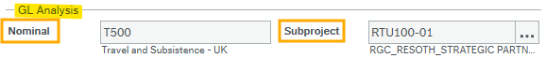
The Image section, only files of type picture or PDF are displayed here.
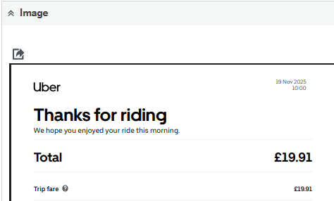
- Alternatively, if no image on display, click on the paperclip icon to view the corresponding receipt evidence, especially for other file types such as Word, Excel or email.
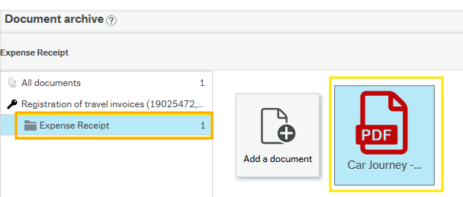



- If you agree with the expense claim details simply click the Approve button at the bottom left of the screen.
- You will then see a message confirming that you have successfully approved the transaction.
- Your tasks will reduce in number after a short processing period.
- The expense claim will progress for payment when it has been approved.

Handling Rejections:

- If you disagree with an expense line, you can reject the claim by simply clicking the Reject button at the bottom left of the screen.
- For a rejected claim, provide a clear reason in the rejection comment text box.
This helps the claimant understand why the claim was refused.
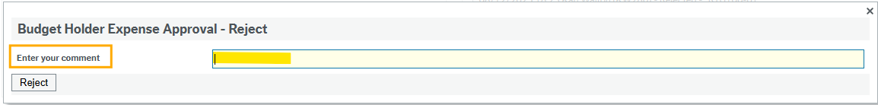
The claim will be returned to the claimant for review along with your comments.

