

Enquiries- Desktop

Training Documentation

Finance System Support

Email - FinanceSystemsSupport@hud.ac.uk

ENQUIRIES

- FIELD HELP
The simplest form of enquiry is the field help screen that comes up when you press F9. This can be used in any field where there is a range of information.
EXAMPLE
Financials / Accounts Payable / Enquiries / Open and historical items per supplier
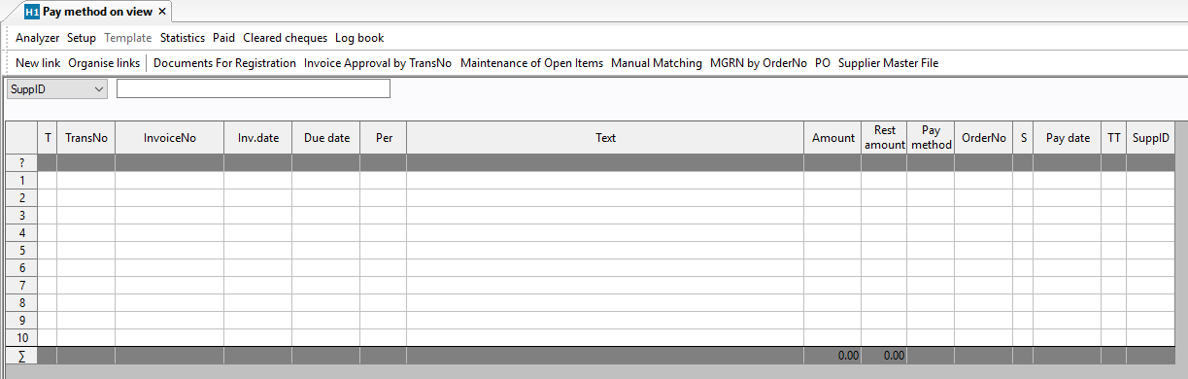

If you want to find a supplier from the enquiry screen, with the cursor in the blank field where the supplier ID is required, press F9. If you press F7 straightaway, every supplier will be displayed and you could scroll down until you find the one you need. Or, before you press F7, you can use the search bar to filter the records by using anything you know about the supplier you are looking for. Use the wild card symbol (*) if you only know part of the name.

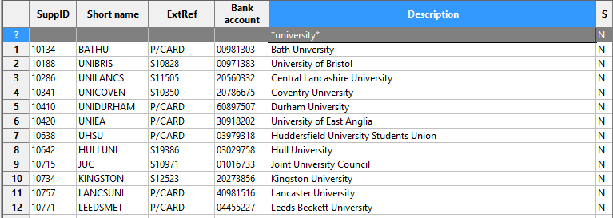
1b.
In this example I am searching for the University of Bristol.
* University * in the description will include in the search any record with University anywhere in the description.
The same method can be used to limit a search anywhere you use F9. Try it to find a Sub-Project or a Nominal Code or a Product Code.

Some Unit4 screens have different Field Help screens e.g. Requisitions Advanced. Pressing F9 in a field brings up a Search screen.

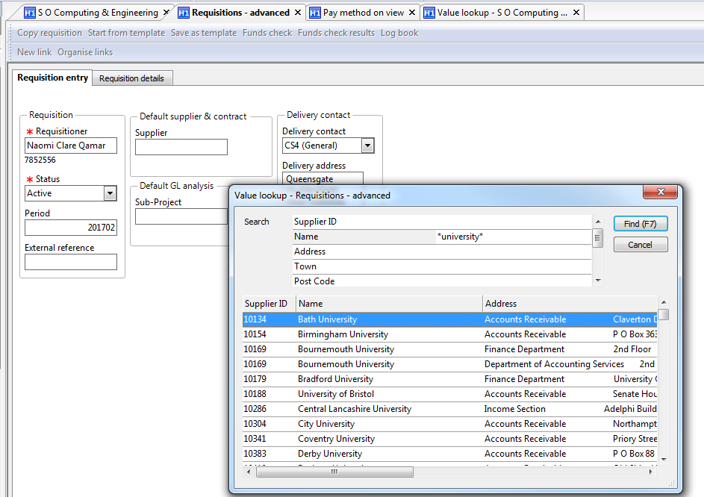

Enter some search criteria and click on the Find button.
- SIMPLE ENQUIRY
Financials / Accounts Payable / Enquiries / Open and historical items per supplier
Each module within Unit4 has an Enquiry option on the menu, which you access by double clicking on the menu item. For example, here’s the Open and historical items per supplier enquiry screen.
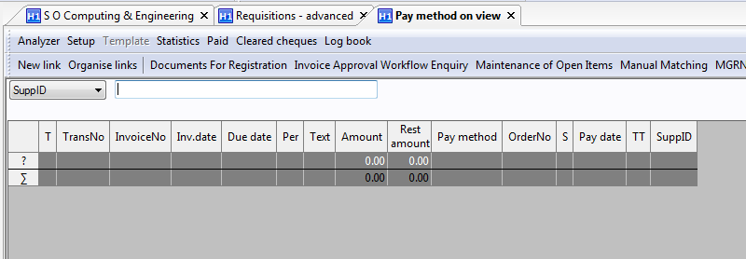
Select all button
Total line
Search bar
(identified by ? and grey background)
EXAMPLE
Search line (identified by ? and grey background)
Enter the Supplier number and tab out of the field. Take out the B from the search bar by clicking on it and pressing the backspace key. ‘Find’ (F7 or binoculars) to populate the table.

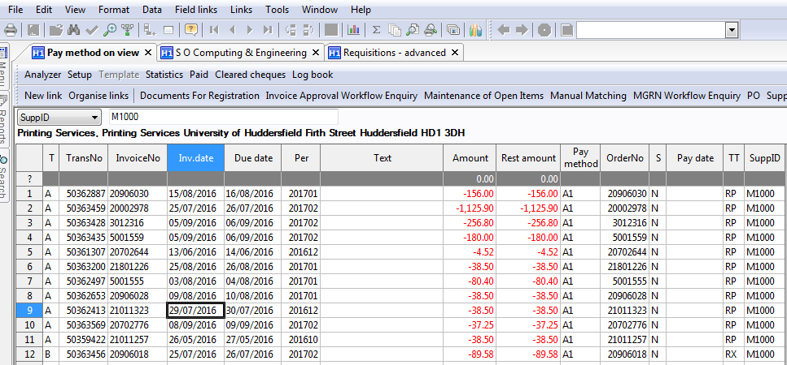
Filter icon
Chart icon

On this screen you can use the grey bar:
-to sort the data .
With the cursor on the heading of the column you want, right mouse click.
–to change the column widths.
With the cursor on the edge of the column you want to resize until the cursor changes, left mouse click, drag and drop.
-to achieve ‘best fit’ of the data in each column.
With the cursor on the select all button, left mouse click.
-to filter the records.
Use the same techniques as you would use the grey search bar in a F9/F7 enquiry.
You can also filter records using a ‘search by example’ facility. If you want, for example, to find all amounts of £117.50, with the cursor on an example of that amount, click the filter icon (or use Data, Filter from the drop down menus). To remove the filter, press F7 or binoculars.

N.B. On the Supplier enquiry screen
A denotes invoices that are on the invoice register, not yet in the purchase ledger.
B denotes invoices that are in the purchase ledger, not yet paid.
C denotes invoices that have been paid.

From this screen you can:

-print the results of your enquiry
Press the print icon (or choose file, print from the drop down menus). Use the drop down menu option to be offered the option of choosing print set up to change from portrait to landscape.
-save the results of your enquiry as an Excel file
From the drop down menu select File, Save as option, select the area you normally save files to and rename the file. The resulting Excel file can then be attached to an e-mail like any other Excel file.

But the big advantage of the on-screen enquiry is that you can
-‘drill down’ and use the Tools menu to get more information about a transaction.

EXAMPLES
Double click on a transaction within the supplier enquiry screen.

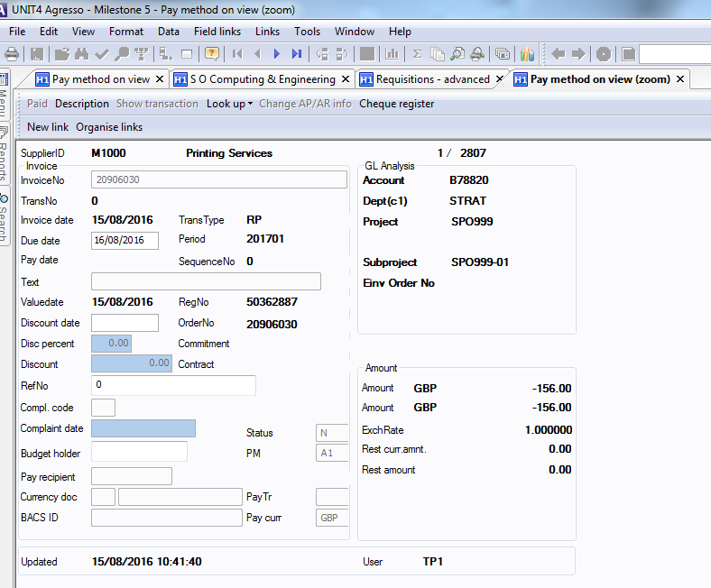

The Tools menu offers various options:
-description allows you to annotate a transaction. Your comment will be visible to all authorised users.
-order allows you to see the originating order

N.B. The options available on the Tools menu will change depending on the stage in the processing that has been reached.
A transactions (Registered invoices not yet on the Purchase Ledger) offers Description and Order
B transactions (Invoices on the Purchase Ledger, not yet paid) offers Description and Show transaction. ‘Show Transaction’ allows you to see which Sub-project/nominal the transaction has been recorded against.
C transactions (Invoices on the Purchase ledger and already paid) offers Description, Order, Show transaction and Paid.

TIP It is always worth trying double-clicking and checking the Tools menu anywhere in any enquiry screen as it’s not possible to detail every option in a set of notes.

The Tools menu from the supplier enquiry screen offers the following options:
-Paid This allows you to check when an invoice was paid.
-Statistics This shows the profile of amounts outstanding for the supplier in graphical form.

CHART ICON

You can convert the results of any enquiry into a chart by clicking on the Chart icon

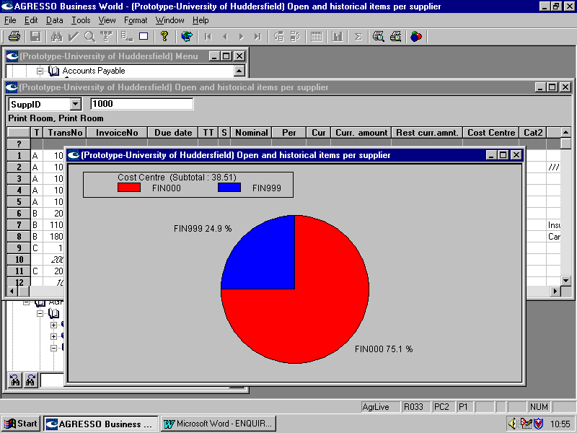
- INFORMATION AVAILABLE FROM THE ORDER

Logistics / Purchasing / Purchase Orders / Entry/Amendment of Purchase Order
Whether you have accessed the order by drilling down from an enquiry or directly from Entry and amendment of purchase orders on the menu, you can see lots of information about the order.
The Info tab on the order summarises transactions relating to that order.

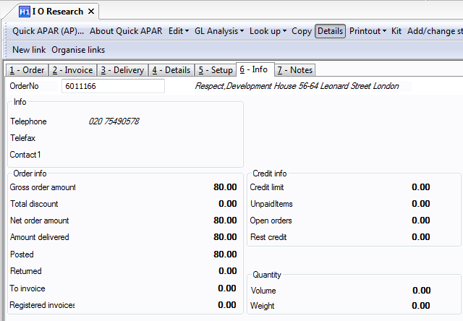
Any amendments made will show here
Deliveries, registered invoices and posted invoices summarised in this section

Choose Tools, Look up, Deliveries to see a list of deliveries with the GRN number.
Choose Tools, Look up, Invoices to see a list of any invoices registered against the order,as
well as any that have been posted to the ledger.

TAILORING AN ENQUIRY TO YOUR SPECIFIC NEEDS
Financials / Accounts Payable / Enquiries / Open and historical items for all suppliers
To access the ‘form’ to tailor an enquiry to your specific needs, choose Tools, Set up from the drop down menu and ‘find’. 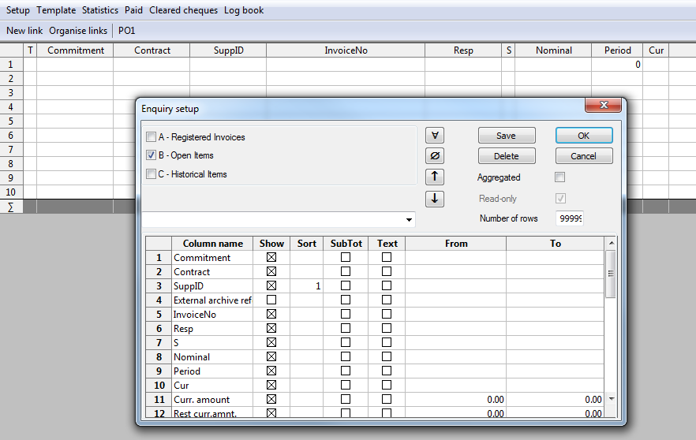
You can use this screen to design a specific enquiry:
Choose which kind of transaction you want to see
You can choose any pre-defined enquiry here
Show all
Show none
Save template
Delete template
Run enquiry
Cancel enquiry
-Column name
This is a list of fields available on the data base, any of which can be column headings on your enquiry. You can change the words if you wish; simply click on the one you want to change and over type.
–Show
Click to put a X in the show column against any column heading you want to see or click to remove the X from any column you don’t want to see.
–Sort
Determine the sort order for the records in your enquiry by putting 1, 2, 3 etc in the sort column against the appropriate column heading.
-Sub Total
Put a X in the Sub Total column against any column heading where you would like a sub total. If you have used this function, the video buttons will be available to view the results of your enquiry at different levels of aggregation.
-Text
Put a X in the Text column against any column heading where you would like to see the name as well as the code for an item of data. For example, you may wish to see the name of a supplier as well as the ID code.
-From/To
Use these columns to select a range of Data items to appear in your enquiry.
HOW TO SAVE A TEMPLATE ENQUIRY
An enquiry that has been tailored to meet specific requirements can be saved as a template. Only the ‘shape’ of the enquiry is saved, each time the template is run it will be populated with current data.
Click the Save button on the enquiry set up screen:
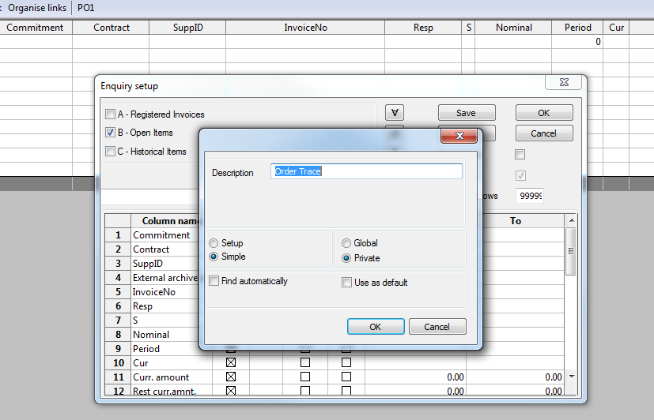Click OK to save the template
As a matter of courtesy NEVER change a template that you have not designed yourself!
The enquiry will now appear on the menu. Access it by clicking on the + sign by the menu item to expand the menu and double click on the named enquiry.
N.B. 1 The same techniques can be used in the General Ledger module to enquire on general ledger transactions
N.B. 2 The same techniques can be used in the Budget module to enquire on budget transactions.
Allocate a name
Choose Private if you want to be the only one to see it
ENQUIRING ON ACTUAL EXPENDITURE AGAINST BUDGET

The only place that you can view actual expenditure against budget is on pre-defined enquiries that you can access via Full Picture by Subproject under the Global Reports pane.
Double click on the year that you wish to see your budget in.
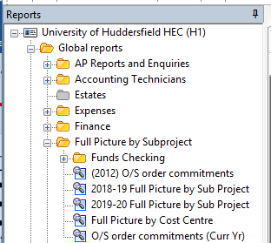
The following screen will open. You will need to click on the binoculars from the toolbar or F7 on your keyboard.

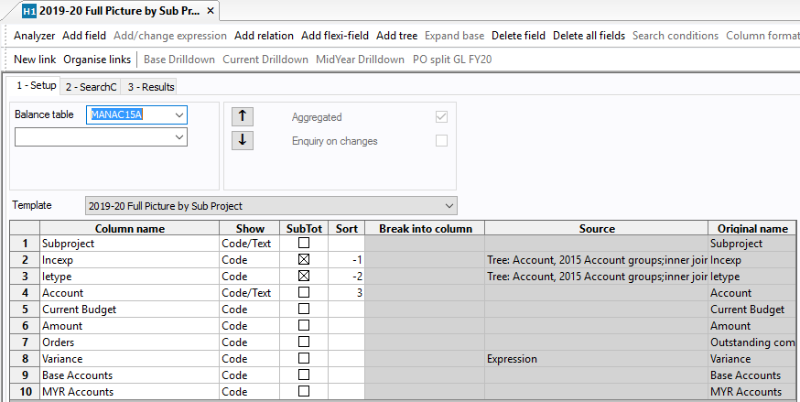

This brings up the pop up box where you type in the Sub-project you want to view.
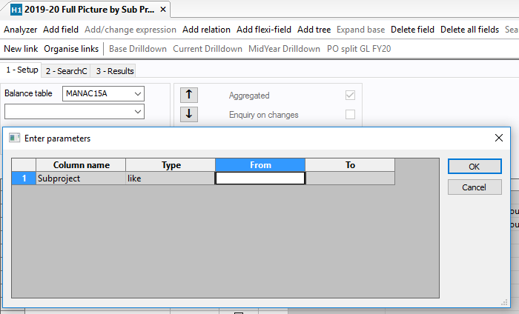

You can drill down and use the options on the Tools menu in the same way as on other enquiry results.
You can use the same filter and charting techniques as on other enquiry results.
You can print and save to Excel files in the same way as on other enquiry results.

